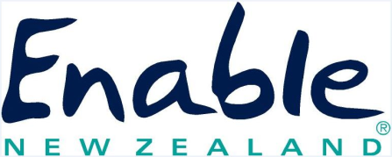 |  |  | ENAE212 | CARE AND USE OF EQUIPMENT  enable@enable.co.nz 0800 362 253
CLIENT DETAILS
Family Name |  |  |  |  | First Name
Street Address |  |  |  |  | Town/City
Postcode |  |  |  |  | Telephone
NHI number |  |  |  |  | Date of Birth
EMS ASSESSOR DETAILS
Name |  |  |  |  | AEA Number
Email |  |  |  |  | Phone
Service / Organisation

- The equipment has been funded by the Ministry of Health and I can use it as long as I need it. I cannot sell it or give it away.
- I cannot have it modified without the knowledge and consent of Enable New Zealand.
- I will arrange insurance for the equipment if I can (high cost items only).
- I will follow the instructions that I have been given on how to use and care for the equipment.
- I will keep the equipment clean and well looked after.
- If I don’t look after the equipment or use it for the purpose it was provided, I will be responsible for all costs associated with the repair and/or replacement and/or componentry.
- Enable New Zealand will coordinate the repair and maintenance of equipment through Ministry of Health funding where this is due to normal wear and tear.
- Repairs are completed in normal business hours (8am – 5pm).

I have discussed with the Specialised Assessor and know what to do if the equipment breaks down after hours, at the weekend or on a Public Holiday.

My After Hours Plan is:

- If I don’t need the equipment any more I will return it to Enable New Zealand or arrange to have it collected. It should be returned because it could be checked and then used by another person.
- If I change my address I will tell Enable New Zealand.
- If I move permanently into residential care (such as a rest home or hospital) I will tell Enable New Zealand as I may have to return some or all of the equipment items I have been using.
- If I leave New Zealand to live overseas, I can take mobility equipment (such as a wheelchair or walking aid), a communication device, glasses, hearing aids or low cost or highly personal equipment (such as a brush, cutlery or easireacher) with me. I will contact Enable New Zealand to arrange the return of all other equipment.
- If my equipment needs to be changed in some way, I will contact the Specialised Assessor or Enable New Zealand and not make any changes to the equipment myself.
- If my equipment needs repairing, or I don’t need the equipment any more, I will contact Enable New Zealand to arrange to have it repaired or collected:

By accepting this equipment you are agreeing to abide by these conditions

Call Free: 0800 362 253
Email: enable@enable.co.nz

